**Life Span of Batteries**

The life span of two brands of batteries was tested in the same type of appliance (e.g., CD player). Ten batteries from each brand, Always Ready and Tough Cell, were tested and their life span was measured in hours.

Each bar represents the life span of a different battery. The ten yellow bars represent batteries from the Tough Cell brand and the ten blue from the Always Ready brand.

In introducing the activity, students can be asked to decide which would be the best type of battery to buy based on the data. A conversation can be held about the factors that students think are important when buying batteries (e.g., cost, life span).

# Lifespan of batteries – sorted by color

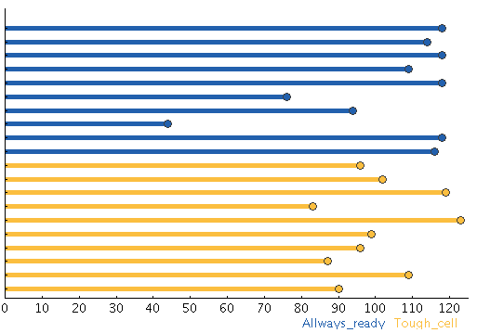

# Lifespan of batteries – sorted by color and size

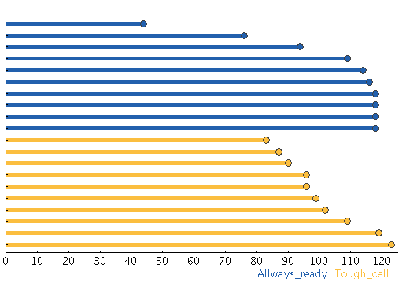

# Lifespan of batteries – sorted by size

